SPEED, DISTANCE and TIME


- Bob the builder was chasing a runaway Dizzy. Bob ran a total of 300 metres in 50 seconds. How fast was he going?
- Dizzy was not the quickest cement mixer. Even though he had a head start on Bob, Dizzy was only able to cover 225 metres in the 50 secs before Bob caught him.. What was Dizzy’s speed?
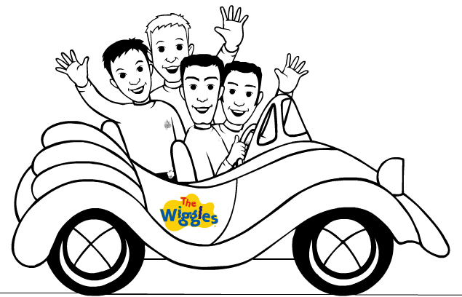
- When Bob discovered Dizzy was missing he phoned the Wiggles, who immediately set off to help in their Big Red Car. The Wiggles were 4 kilometers away, and made it to Bob in only 200 secs. What was their speed?
- When the Wiggles arrived, the local policeman Inspector Detector was waiting for them. He booked the wiggles for going over the 60 km/hr speed limit. Is this right? How much over or under the limit were they?
This is a tougher question

- The Wiggles were not very happy at being booked by Inspector Detector so they drove back home (4 kms away) at 12 m/s. how long did it take them to get home?
- Bob was sick of Dizzy by now and loaded him up in the back of Lofty. Together Bob and Lofty went to build a new barn for farmer Pickles. They set off at 5 m/s. They had only been going for 45 secs when Spud leapt out from the bushes and scared Lofty so much that Dizzy fell off the back. How far had they gone?

SPEED, DISTANCE and TIME

- Bob the builder was chasing a runaway Dizzy. Bob ran a total of 300 metres in 50 seconds. How fast was he going?
- Dizzy was not the quickest cement mixer. Even though he had a head start on Bob, Dizzy was only able to cover 225 metres in the 50 secs before Bob caught him.. What was Dizzy’s speed?
- When Bob discovered Dizzy was missing he phoned the Wiggles, who immediately set off to help in their Big Red Car. The Wiggles were 4 kilometers away, and made it to Bob in only 200 secs. What was their speed?
- When the Wiggles arrived, the local policeman Inspector Detector was waiting for them. He booked the wiggles for going over the 60 km/hr speed limit. Is this right? How much over or under the limit were they?
This is a tougher question
- The Wiggles were not very happy at being booked by Inspector Detector so they drove back home (4 kms away) at 12 m/s. how long did it take them to get home?
- Bob was sick of Dizzy by now and loaded him up in the back of Lofty. Together Bob and Lofty went to build a new barn for farmer Pickles. They set off at 5 m/s. They had only been going for 45 secs when Spud leapt out from the bushes and scared Lofty so much that Dizzy fell off the back. How far had they gone?

